## Intclust 6 potential mislabelling issue

Allan is working on the below cell lines:

**Positive controls (ZNF703 amplified):**

MDA-MB-134

Allan and Feung are of the opinion that these cell lines might be more correctly classified into IntClust 6, but this is apparently not the case from the CN-only/exp-only classifier.

HCC1500

BT-483

CAMA-1

MFM-223

**Negative controls (ZNF703 copy number neutral):**

MCF7 (known to be luminal)

ZR-75-1 (known to be luminal)

BT-474 (known to be HER2+)

### ZNF703 expression overview (n = 56)



### kmeans clustering

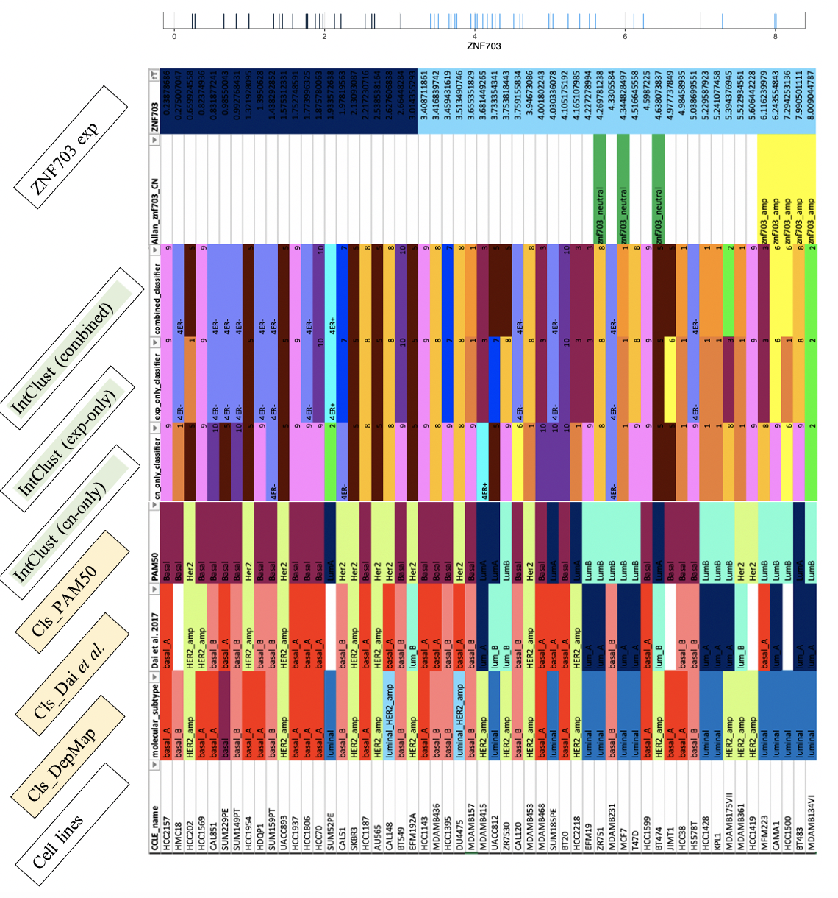

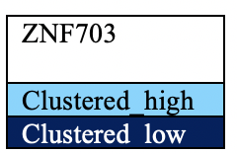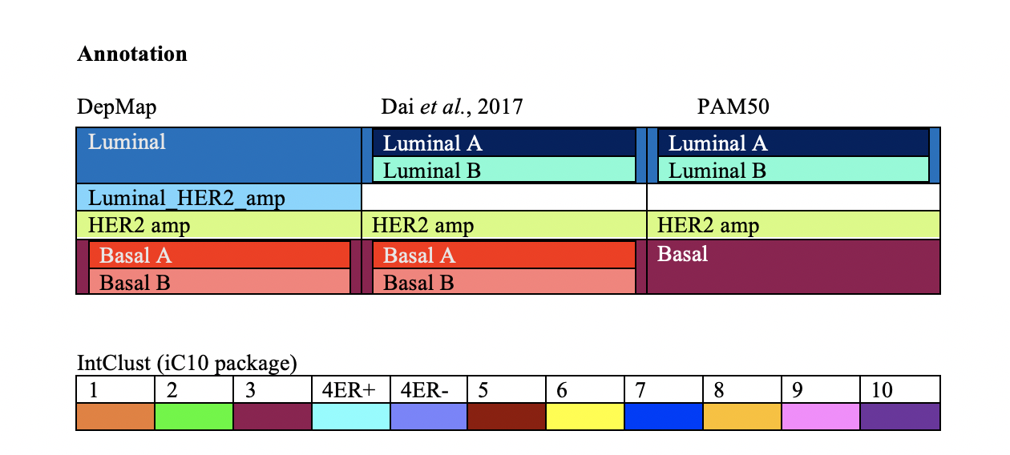

Note:

* Both DepMap and Dai et al. labelled BCCL with 5 subtypes; but in the latter, the classification scheme doesn’t include ‘luminal_HER2_amp’ but instead separate luminal group to A and B.
* Under DepMap HER2 status column, there is a cell highlighted with HERneg (+):
  + This highlights the inconsistency between DepMap and Dai et al. marker annotation (the latter indicated in bracket).

****

### hierarchical clustering

reveals similar cutoff as kmeans.